Algebra 3 Unit 2 Quiz 3   
Put answers on a separate sheet.

Level 2

1. Sketch a graph with at least 8 points that shows a negative correlation.
2. Sketch a graph with at least 8 points that shows no correlation.
3. 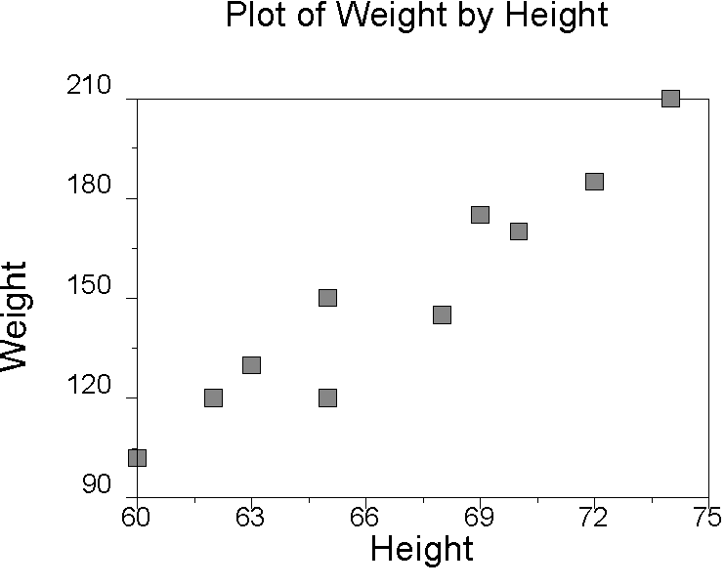Describe the correlation.

Level 3

Plot the points and describe the correlation

1. {(2, 4), (3, 5), (5,12), (0, 1), (7, 13), (4, 8)}

Level 4

Plot the points and describe the correlation

1. Write the equation of the line that best fits the points in problem 4. 7